Chapter 1: The History of The Villages of Citrus Hills
The Villages of Citrus Hills is not just a neighborhood—it's the realization of a visionary dream, a legacy of two entrepreneurial spirits who reimagined retirement living in Central Florida. The story begins in the late 1960s, when Sam Tamposi, Sr. and Jerry Nash, two seasoned businessmen from New England and part-owners of the Boston Red Sox, began flying over the state of Florida in their private DC-3 airplane, scouting for the perfect piece of land to create a new kind of master-planned community.
During one of these scouting trips, they discovered a landscape unlike anything they had expected in Florida—gently rolling hills, towering live oaks draped in Spanish moss, and sweeping views that extended for miles. This hidden gem of Citrus County, just a few miles from the Gulf of Mexico, immediately captured their imagination. It was the ideal canvas for what would become The Villages of Citrus Hills.
By the early 1980s, their vision began to take shape. Tamposi and Nash were determined to create a community that offered more than just homes—it would offer a lifestyle. They dreamed of a place where friends, family, and future neighbors could enjoy a vibrant, active way of life surrounded by beautiful scenery and first-class amenities.
To help promote their vision, the founders enlisted the help of a close friend and baseball legend—Ted Williams, the Boston Red Sox Hall-of-Famer and avid fisherman. Williams became the face of Citrus Hills, promoting the community to fellow New Englanders through a popular "fly-down" program that brought thousands of prospective buyers from the Northeast to Florida. His celebrity status, along with the community's natural beauty and growing list of amenities, helped transform Citrus Hills into one of the most successful master-planned communities in the state.
Unlike many Florida communities, The Villages of Citrus Hills is privately held, free of debt, and financially strong. The developer owns all the major amenities and has invested over $100 million in infrastructure and resort-style facilities—investments that continue today with new projects like the upcoming resort pool and poolside restaurant in Davis Reserve. Importantly, Citrus Hills has no CDD fees, setting it apart from many other large-scale retirement developments in Florida.
What began with one central amenity has grown into a thriving community of over 10,000 homes with four world-class amenity campuses and a fifth on the way. These include golf courses, wellness and fitness centers, a 50,000 sq. ft. spa, restaurants, dog parks, pickleball and tennis courts, and an ever-expanding calendar of social events, classes, and clubs.
While The Villages of Citrus Hills is not a mandated 55+ community, it is a targeted active adult community—with over 80% of residents aged 55 and older. It offers a unique lifestyle marked by tranquility, elegance, and activity, designed for those who want to enjoy their retirement without the crowds or congestion of larger developments.
Today, the Tamposi family continues to lead Citrus Hills with the same commitment to quality and community that Sam Tamposi and Jerry Nash instilled decades ago. Their dream lives on in the rolling green fairways, the laughter at the Tiki Bar, the quiet mornings spent walking the nature trails, and the sense of pride shared by the residents who now call Citrus Hills home. It is more than a place to live—it’s a legacy, and it continues to grow with every new neighbor who discovers it.
Chapter 2: The Villages of Citrus Hills – Where Luxury Meets Everyday Living
Welcome to the Villages of Citrus Hills, an exceptional community that combines luxury with daily living. This meticulously designed haven spares no expense in offering you a perpetual vacation-like experience. Here, you'll find an active lifestyle crafted to enhance your well-being, ensuring you make the most of your retirement.
New and Resale Homes
- New Homes: Starting from the high $400,000s and up, these brand-new residences offer modern living and cutting-edge design.
- Resale Homes: Priced at $200,000 and above, these pre-owned homes provide a variety of options to suit your preferences.
- Carefree Homes: Available in Terra Vista and Brentwood Villages only, these homes provide a low-maintenance living option, perfect for those seeking a hassle-free lifestyle.
- Pet-Friendly: Most areas within the Villages of Citrus Hills welcome your furry companions, with the exception of Greenbriar condos where no dogs are allowed.
Dog Park
- Enjoy the company of your four-legged friends in the designated dog park, offering a space for your pets to play and socialize.
Security Guard and Security Gates
- Rest easy with the added peace of mind provided by security guards and gated entrances, ensuring a safe and secure community.
Championship Golf Courses
- Immerse yourself in golfing excellence with three championship courses that challenge and delight players of all skill levels.
- Additionally, an executive course provides a different golfing experience for those looking to enjoy a quick round.
Dining Options
- Savor culinary delights at the Villages' three exceptional restaurants, each offering a unique dining experience:
  - The Tiki: Located in the vibrant Activity Center, this is a resident favorite for casual dining.
  - The Grille: An upscale restaurant, perfect for special occasions and fine dining.
  - Skyview Restaurant: Offering picturesque views and delicious fare, it's the perfect place to unwind.
HOA Fees
- HOA fees vary by village, ranging from $20 per month to $480 per month. These fees help maintain the community and its amenities.
Social Membership
- A social membership, deeded with the home, adds to the vibrant community experience. This membership comes with a monthly fee of $189 and a one-time $2,000 deposit when you purchase your home.
Terra Vista Golf Cart Community
- Terra Vista is the exclusive golf cart community within the Villages of Citrus Hills, allowing for convenient and eco-friendly transportation.
Outdoor and Indoor Pools
- Enjoy outdoor swimming at the Activity Center's pool and anticipate the arrival of an upcoming resort-style pool with a cabana bar for a refreshing experience.
- Indoor pool, a hot tub, wet and dry saunas, and resort-style locker rooms are available, along with a 50,000-square-foot spa and fitness center, providing a sanctuary for health and rejuvenation at the Bella Vita Spa and Fitness Center.
World-Class Amenities
The Villages of Citrus Hills has world-class resort-style amenities that elevate your retirement experience. These amenities include:
- Bella Vita Spa and Fitness Center: A luxurious spa and fitness center, spanning over 50,000 square feet, offering a serene space for health and relaxation.
- The Grille Restaurant: A dining establishment perfect for special occasions and fine dining.
- Tiki Bar: A vibrant outdoor venue, a favorite among residents.
- Prima Vito Fitness Center: A fitness center, ensuring you stay active and healthy.
- Skyview Golf Course: A top-tier golf course with a pro shop, offering golfing enthusiasts a fantastic experience.
- Activity Center: The hub of entertainment, featuring the outdoor pool, pickleball, a golf simulator, billiards, card rooms, a library, and a magnificent ballroom equipped with a stage for various events, overseen by the activity director.
The Villages of Citrus Hills has grown from a single central amenity to having four resort-style amenities, with another on the way, accommodating over 10,000 homes. The legacy of Sam Tamposi continues to be carried forward by the Tamposi family. Here, every day feels like a holiday, with a wide array of amenities designed to cater to your every need, making it a dream retirement destination.

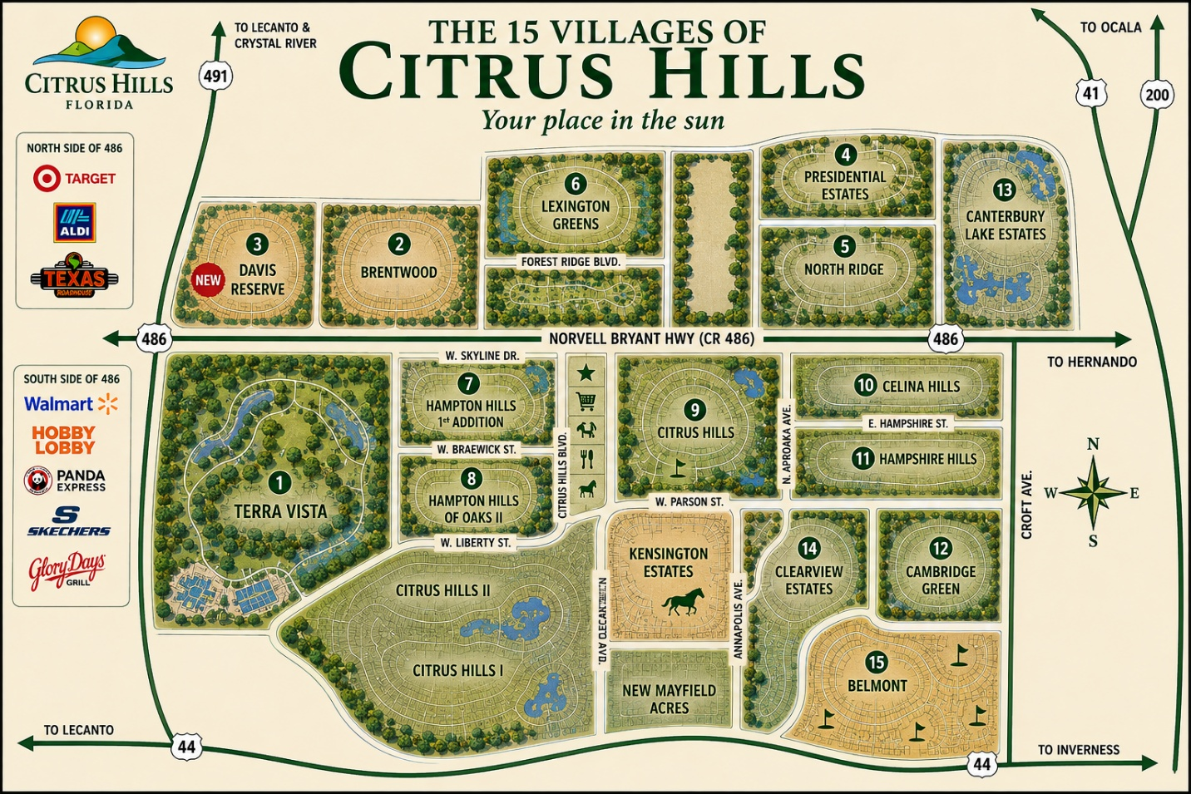
Chapter 3: Exploring the 15 Villages of Citrus Hills
The Villages of Citrus Hills is a master-planned community in Hernando, Florida, comprising 14 distinct villages, each offering unique characteristics to suit diverse lifestyles. From gated enclaves with resort-style amenities to expansive estates with equestrian trails, there's a neighborhood for every preference. Below is an overview of each village, followed by a comparative chart highlighting key features.(Citrus Hills Info)

Village Overviews
- Belmont: An equestrian-themed, gated community featuring triple split-rail fences and large lots ranging from 0.5 to over 1 acre. Located adjacent to Gulf to Lake Highway, it's close to shopping centers like Walmart and Lowe's. (Citrus Hills Info)
- Brentwood: A gated village offering care-free living with homes on lots less than a quarter-acre. Amenities include a community pool, hot tub, fitness area, and a 9-hole golf course. Most homes have a mandatory social membership. (Citrus Hills Info)
- Canterbury Lakes: Situated in Hernando, this village offers quarter-acre lots, a community center, and pool. Unique for its RV and boat storage, available exclusively to residents. (Neighborhoods, Citrus Hills Info)
- Cambridge Greens: Located south of Norvell Bryant Highway, it features half-acre wooded lots. Notably, it's undergoing a mandatory septic-to-sewer conversion. (Citrus Hills Info)
- Celina Hills: The most easterly village south of Norvell Bryant Highway, offering quarter-acre and larger lots.
- Citrus Hills: The original village, home to the Oaks and Meadows golf courses, Tiki Bar, Grille, and Primo Vita fitness center. Lots are generally half an acre, many overlooking the golf course. (Citrus Hills Info)
- Clearview Estates: Features estate homes on one-acre lots with three miles of equestrian trails and a privately owned horse stable. Natural gas is available for most homes. (Citrus Hills Info)
- Emerald Estates: Located in the southwestern part of Citrus Hills, offering a tranquil lifestyle with access to the Citrus Hills Golf and Country Club amenities. (Citrus Hills Info)
- Fairview Estates: The northernmost village, situated just minutes from downtown Inverness. Residents enjoy picturesque landscapes and access to Citrus Hills amenities. (Citrus Hills Info)
- Fox Run: Comprises one-acre wooded lots, providing natural privacy and a country feel. (Citrus Hills Info)
- Hampton Hills: Known for large estate homes on wooded one-acre lots, offering a premier living experience outside of Terra Vista. (Citrus Hills Info)
- Kensington Estates: Unique for having no HOA or deed restrictions, featuring one-acre lots. Residents can park boats or RVs in their driveways. (Citrus Hills Info)
- Presidential Estates: Highly sought after for its lack of mandatory HOA fees and deed restrictions. Offers one-acre lots and allows boat or RV parking in driveways. (Citrus Hills Info)
- Terra Vista: The premier gated community with a manned security gate, allowing golf cart usage. Boasts world-class amenities, including a 55,000 sq. ft. spa and fitness center. (Citrus Hills Info)
- Davis Reserve – The newest community in the Villages of Citrus Hills. There will be an outdoor pool with a Cabana Bar with beverage and food service.

Community Comparison Chart
Village | HOA Fees (Monthly) | Lot Sizes | Gated Community | Care-Free Living | Golf Access | RV/Boat Storage | Deed Restrictions
Belmont | Varies | 0.5 - 1+ acre | Yes | No | Optional | No | Yes
Brentwood | $310 | <0.25 acre | Yes | Yes | Yes | No | Yes
Canterbury Lakes | Varies | ~0.25 acre | No | No | Optional | Yes | Yes
Cambridge Greens | Varies | 0.5+ acre | No | No | Optional | No | Yes
Celina Hills | Varies | 0.25+ acre | No | No | Optional | No | Yes
Citrus Hills | Varies | ~0.5 acre | No | No | Yes | No | Yes
Clearview Estates | Varies | 1 acre | No | No | Optional | No | Yes
Emerald Estates | Varies | Varies | No | No | Optional | No | Yes
Fairview Estates | Varies | Varies | No | No | Optional | No | Yes
Fox Run | Varies | 1+ acre | No | No | Optional | No | Yes
Hampton Hills | Varies | 1 acre | No | No | Optional | No | Yes
Kensington Estates | None | 1 acre | No | No | Optional | Yes | No
Presidential Estates | Voluntary ($30/yr) | 1 acre | No | No | Optional | Yes | No
Terra Vista | $258 + HOA | Varies | Yes (Manned) | Optional | Yes | No | Yes
Note: "Care-Free Living" refers to maintenance-free homes where services like lawn care and exterior maintenance are included. "Golf Access" indicates proximity or access to golf courses; fees may apply. "RV/Boat Storage" availability varies; some communities offer on-site storage, while others may allow parking on property.

Each village within the Villages of Citrus Hills offers a unique living experience, catering to a variety of preferences and lifestyles. Whether you seek the luxury amenities of Terra Vista, the equestrian charm of Belmont, or the freedom of no HOA in Kensington Estates, there's a community tailored for you.(Citrus Hills Info)
For more detailed information on each village, including available homes and specific HOA details, please visit Citrus Hills Info.

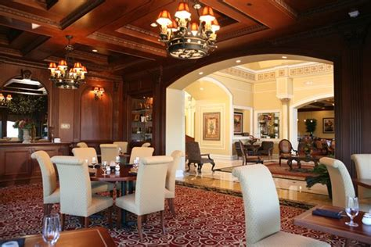
Chapter 4: Terra Vista of Citrus Hills – A Premier Gated Community
Terra Vista, nestled within the Villages of Citrus Hills in Hernando, Florida, epitomizes luxury living on Florida's Nature Coast. This exclusive, gated community offers residents panoramic views, world-class amenities, and a vibrant social scene, all designed for those seeking an active and upscale lifestyle.(Citrus Hills Info)

🌟 Overview of Terra Vista
- Location: Hernando, Florida
- Community Type: Gated, not age-restricted (with select 55+ neighborhoods)
- Key Amenities:
  - Bella Vita Spa & Fitness Center (50,000 sq. ft.)
  - Skyview Golf Course (18 holes)
  - Indoor & outdoor pools
  - Tennis, pickleball, racquetball courts
  - Fine dining at Skyview Restaurant
  - Extensive walking and biking trails
- Home Types: Maintenance-free villas, detached courtyard homes, custom estate homes
- Home Sizes: Approximately 1,500 to over 4,000 sq. ft.
- HOA Fees:
  - Terra Vista Master Fee: $258/month (includes basic internet and cable)
  - Neighborhood HOA: Varies ($11–$205/month)
  - Social Membership: $189/month
- Pet Policy: Pet-friendly community(nextdoor.com, Citrus Hills Info, Citrus Hills Info, Citrus Hills Info, Citrus Hills Info, Citrus Hills Info)

🏘️ Neighborhoods within Terra Vista
Terra Vista comprises several distinct neighborhoods, each offering unique features and lifestyles:(Citrus Hills Info)
Care-Free Neighborhoods (HOA handles exterior maintenance)
- Hillside Villas: Attached villas with modern designs, ideal for those seeking low-maintenance living.
- Lakeview Villas: Homes offering serene lake views and proximity to walking trails.
- Skyview Villas: Located near the Skyview Golf Course, these villas provide easy access to golfing amenities.
- Southgate Villas: Central location with a mix of attached and detached homes, close to Rockwood Park.
- Westford Villas: Features decorative fencing options and a community-focused atmosphere.
- Woodview Villas: Nestled among wooded areas, offering privacy and natural beauty.(Citrus Hills Info)
Non Care-Free Neighborhoods (Homeowners manage their own maintenance)
- Bobbie Glen: The newest addition to Terra Vista, currently under development with modern homes.
- Bellamy Ridge: Gated community with luxurious single-family homes starting in the $700,000s, some with golf course views.
- Foxfire: Established neighborhood with custom homes on larger lots, offering privacy and proximity to Bella Vita Spa.
- Hunt Club: Exclusive enclave near Rockwood Park, known for its spacious homesites and tranquil setting.
- Nash Crossing: A gated 55+ community offering a peaceful environment for active adults.
- Roberts Ridge: Gated community with homes overlooking the Skyview Golf Course, providing scenic vistas.(Citrus Hills Info)
55+ Only Neighborhoods
- Hall's Reserve: Age-restricted gated community designed for active adults seeking a vibrant lifestyle.
- Nash Crossing: Combines the benefits of a 55+ community with the amenities of Terra Vista.
- Griffin View: Gated neighborhood offering privacy and tailored amenities for residents aged 55 and over.(Citrus Hills Info)

📊 Comparison Chart of Terra Vista Neighborhoods
Neighborhood | Care-Free | Gated | 55+ Only | Home Type | Notable Features
Bobbie Glen | No | No | No | Single-family homes | Newest development, modern designs
Bellamy Ridge | No | Yes | No | Luxury single-family | Golf course views, spacious lots
Foxfire | No | No | No | Custom single-family | Larger lots, near Bella Vita Spa
Hunt Club | No | No | No | Single-family homes | Near Rockwood Park, tranquil setting
Nash Crossing | No | Yes | Yes | Single-family homes | 55+ community, peaceful environment
Roberts Ridge | No | Yes | No | Single-family homes | Overlooks Skyview Golf Course
Hillside Villas | Yes | No | No | Attached villas | Modern designs, low-maintenance living
Lakeview Villas | Yes | No | No | Villas | Serene lake views, walking trails nearby
Skyview Villas | Yes | No | No | Villas | Proximity to Skyview Golf Course
Southgate Villas | Yes | No | No | Attached/detached | Central location, near Rockwood Park
Westford Villas | Yes | No | No | Villas | Decorative fencing, community atmosphere
Woodview Villas | Yes | No | No | Villas | Wooded surroundings, privacy
Hall's Reserve | No | Yes | Yes | Single-family homes | Age-restricted, vibrant lifestyle
Griffin View | No | Yes | Yes | Single-family homes | Gated, tailored amenities for 55+ residents

For more detailed information on each neighborhood, including available homes and specific amenities, please visit Citrus Hills Info.(Citrus Hills Info)


Chapter 5: The Citrus Hills Social Membership – Your Keys to the Kingdom
Imagine unlocking a lifestyle where every day feels like a vacation—where resort-style amenities, vibrant social events, and wellness opportunities are just steps from your door. In the Villages of Citrus Hills, this dream becomes reality through the Citrus Hills Social Membership, often referred to as "The Keys to the Kingdom."

What Is the Citrus Hills Social Membership?
The Citrus Hills Social Membership is a deeded privilege tied directly to your home, granting access to an array of exclusive amenities within the community. It's important to note that this membership cannot be purchased separately; it must be conveyed with the property. Outside of Terra Vista, only about half of the homes in Citrus Hills come with a social membership. Therefore, verifying the presence of this membership before purchasing is crucial.

Membership Costs and Deposit
Upon purchasing a home with a social membership, a one-time refundable deposit of $2,000 is required. This deposit is returned when you sell your home. In addition to the deposit, members pay quarterly dues of $565.57 (approximately $188.52 per month, including tax). These dues are separate from any HOA fees and are paid directly to the developer, who owns and maintains the amenities.(Citrus Hills Info)

Access to Premier Amenities
Holding the social membership opens the door to a host of facilities and activities:
- Bella Vita Spa and Fitness Center: A 55,000-square-foot facility featuring state-of-the-art fitness equipment, indoor pool, hot tub, saunas, racquetball courts, and a full-service spa offering massages, facials, and nail services.
- PrimoVita Fitness Center: A more intimate gym equipped with advanced cardio machines, circuit training stations, free weights, and innovative Power Plate technology.(Citrus Hills Info)
- Brentwood Fitness Center and Pool: Offers a heated outdoor pool, hot tub, saunas, and a well-equipped fitness center for a comprehensive wellness experience.
- Activity Center: The community hub featuring a heated outdoor pool with lap lanes, hot tub, pickleball and POP tennis courts, billiards room, card and craft rooms, library, and a state-of-the-art golf simulator.(Citrus Hills Info)
- Dining Venues: Access to exclusive dining experiences at Skyview Restaurant and The Grille, both offering a variety of culinary delights in elegant settings.(Citrus Hills Info)
- The Tiki Bar: A lively spot for socializing, featuring live entertainment, a full bar, and a casual dining atmosphere.(Citrus Hills Info)
- Rockwood Park: A recreational area with bocce courts, walking trails, a lake for RC boat racing, playground, beach volleyball court, and a themed dog park.(Citrus Hills Info)
- Golf: Members enjoy discounted rates on three 18-hole golf courses and a 9-hole course, with complimentary greens fees on the Meadows Course (cart rental required).

Important Considerations
- Deeded Membership: The social membership is tied to the property deed and cannot be transferred independently.
- Optional Memberships: Some homes offer optional memberships, which must be activated within 30 days of purchase. Failure to do so results in the permanent loss of eligibility.(Citrus Hills Info)
- Continuous Membership: Once activated, the membership must be maintained continuously; lapsing results in forfeiture.
- Guest Policy: Guests must reside more than 60 miles away, are limited to four visits per year (no more than one week per visit), and must be accompanied by the member at all times.(Citrus Hills Info)

Embracing the Citrus Hills Social Membership truly provides "The Keys to the Kingdom," offering an unparalleled lifestyle filled with luxury, wellness, and community engagement. Whether you're seeking relaxation, fitness, or social interaction, this membership ensures that every day is enriched with opportunities to enjoy the best that Citrus Hills has to offer.

